ARYAMAN MISHRA

19BCE1027

Network and Communications LAB 1

Under guidance of

[Dr. Jayalakshmi SL & Prof. Rajesh Kumar (L61+L62+L63)](https://lms.vit.ac.in/course/view.php?id=50#section-7)

Differences in Hub,Switch and Router

|  |  |  |  |
| --- | --- | --- | --- |
| Differences on basis of | Hub | Switch | Router |
| Layer | Physical layer | Data link layer | Network layer |
| Function | To connect a network of personal computers together, they can be joined through a central hub | Allow connections to multiple devices, manage ports, manage VLAN security settings | Direct data in a network |
| Data Transmission form | electrical signal or bits | frame & packet | packet |
| Port | 4/12 ports | multi-port, usually between 4 and 48 | 2/4/5/8 ports |
| Transmission type | Frame flooding, unicast, multicast or broadcast | First broadcast, then unicast and/or multicast depends on the need | At Initial Level Broadcast then Uni-cast and multicast |
| Device type | Non-intelligent device | Intelligent device | Intelligent device |
| Used in(LAN, MAN, WAN) | LAN | LAN | LAN, MAN, WAN |
| Transmission mode | Half duplex | Half/Full duplex | Full duplex |
| Speed | 10Mbps | 10/100Mbps, 1Gbps | 1-100Mbps(wireless); 100Mbps-1Gbps(wired) |
| Address used for data transmission | MAC address | MAC address | IP address |

Commands performed in Ubuntu(Windows and Virtualbox)

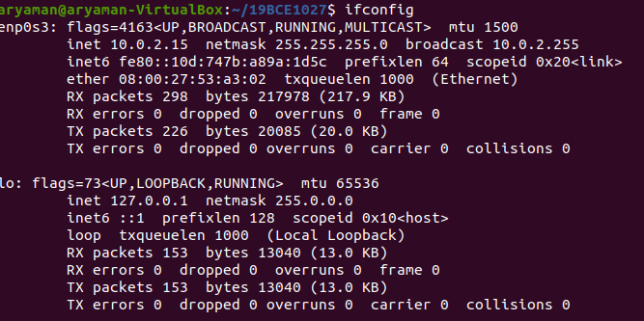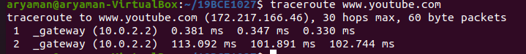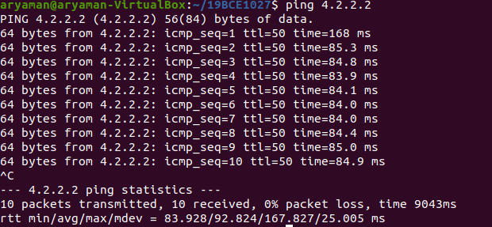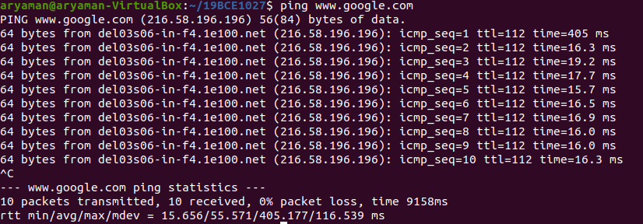

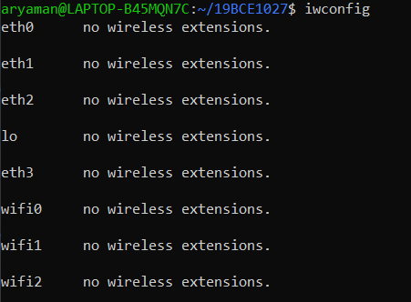C:\Users\aryam\Desktop\Fall Semester 2020-21\Network and Communications Lab\Lab1\10.PNG